**3.3 TABLE DESCRIPTION**

student:

|  |  |
| --- | --- |
| Table name | student |
| Description | This table stores the information about the student. |
| Attributes | name ( varchar(20))  usn (varchar(20)), section (varchar(20)), partner_usn ( varchar(20))  project_id ( int(10)) |
| Primary key | usn |
| Foreign key | partner_usn , project_id |

project:

|  |  |
| --- | --- |
| Table name | project |
| Description | This table stores the information about the project. |
| Attributes | project_id ( int(10))  usn_1 (varchar(20)), usn_2 (varchar(20)), project_name( int(10))  guide_id ( varchar(20)) |
| Primary key | project_id |
| Foreign key | usn_1, usn_2, guide_id |

guide:

|  |  |
| --- | --- |
| Table name | guide |
| Description | This table stores the information about the guide. |
| Attributes | name( varchar(20)),  emp_id ( int ),  project_id ( int(10)) |
| Primary key | emp_id |
| Foreign key | project_id |

marks secured:

|  |  |
| --- | --- |
| Table name | marks secured |
| Description | This table stores the information about the marks secured |
| Attributes | phase_1 ( int (3)), phase_2 ( int (3)),  phase_3 ( int (3)), project_id ( int(10)), submission ( varchar(20)) |
| Primary key | null |
| Foreign key | project_id |

review:

|  |  |
| --- | --- |
| Table name | review |
| Description | This table stores the information about the review. |
| Attributes | review_id ( varchar(20)), rating (int(2)), suggestion( varchar(30)),  project_id( int(10)), reviewer_type ( varchar(20)). |
| Primary key | null |
| Foreign key | project_id , review_id |

**3.4 Functional and non-functional requirements**

**3.4.1 Functional requirements**

Since this project uses database and control, it needs the retrieval of information from the database. It needs access of Database from a frontend through JDBC an application of java. It provides easy linking to the database, along with the flexibility required to develop user-friendly frontend.

**3.4.2 Non-functional requirements**

* **Usability:** The interface should use terms and concepts, which are drawn from the experience of the people who will make most of the system.
* **Efficiency:** The system must provide easy and fast access without consuming more cost.
* **Reliability:** User should never be surprised by the behaviour of the system and it is easy to store data.
* **Security:** This system is provided with authentication without which no user can pass. So only the legitimate users are allowed to use the application. If the legitimate users share the authentication information then the system is open to outsiders.

**CHAPTER 4:**

**IMPLEMENTATION**

**4.1 DATABASE IMPLEMENTATION**

There are 5 tables in the database and one stored procedure.

**1.student**

This table contains the information about the student , who is doing the project. The attributes of this table are USN(id of the student),name(Name of the student), partner_USN( USN of the partner). Here USN is the primary key.

**2.guide**

This table contains the information about the guide. The attributes of this table are guide id(id of the employee), Guide’s name(fname and lname of the artist). Here guide id is the primary key.

**3.project**

This table contains the information about the project. The attributes of this table are art id (id of the project), project name(name of the project), USN1(USN of the first student), USN2( USN of the second student). Here project_id is primary key.

**4. marks secured**

This table contains information about the marks allotted for the particular project in particular phase. The attributes of this table are projectid(id of project), phase 1(phase 1 allotted marks), phase 2(phase 2 allotted marks), phase 3(phase 3 allotted marks). Here project id is the primary key.

**5.review**

This table contains information about the review of very project. The attributes of this table are review id( id of the emplyoee), project id(id of the project), rating(rating for every project out of 5). Here review id is referred as the primary key, project id is referred as foreign key.

The stored procedure is about listing the all projects stored in the database. By calling the procedure, projects will be listed out.

**4.2 Front End Implementation**

**Menu.java**

This is the home page of our project. It shows 2 buttons those are Start / Exit.

**Menu2.java**

The welcome page is the home page which contains 3 buttons, Insertion, Procedure, Queires

**1.StudentInsertion.java**

Itadds or updates or deletes the details of the student. In this page we can add new entries as well as view the existing records. Insert button is used to insert the details about new student to the database. Update button perform update operation and delete perform delete operation. Back button is used to go back to previous page. Beside table displays the whole table.

**2.GuideInsertion.java**

It adds or updates or deletes the details of the guide. In this page we can add new entries as well as view the existing records. Insert button is used to insert the details about new guide to the database.Update button perform update operation and delete perform delete operation. Back button is used to go back to previous page. Beside table displays the whole table.

**3.project.java**

It adds or updates or deletes the details of the project. In this page we can add new entries as well as view the existing records.Update button perform update operation and delete perform delete operation.Insert button is used to insert the details about new projectto the database. Back button is used to go back to previous page. Beside table displays the whole table.

**4.Marks_Secured.java**

It adds or updates or deletes the details of the marks secured. In this page we can add new entries as well as view the existing records. Insert button is used to insert the details about marks secured.Update button perform update operation and delete perform delete operation. Back button is used to go back to previous page. Beside table displays the whole table.

**5.review.java**

It adds or updates or deletes the details of the review. In this page we can add new entries as well as view the existing records. Insert button is used to insert the details about review.Update button perform update operation and delete perform delete operation. Back button is used to go back to previous page. Beside table displays the whole table.

**6. Query1.java**

This displays the total marks allotted for each project after completing all the phases.

**7. Query2.java**

This displays the details of the of the Guide and name of the project for a particular USN.

**8. proc.java**

This list out all the projects available in the database. This is a stored procedure.

**CHAPTER 5:TESTING AND RESULT ANALYSIS**

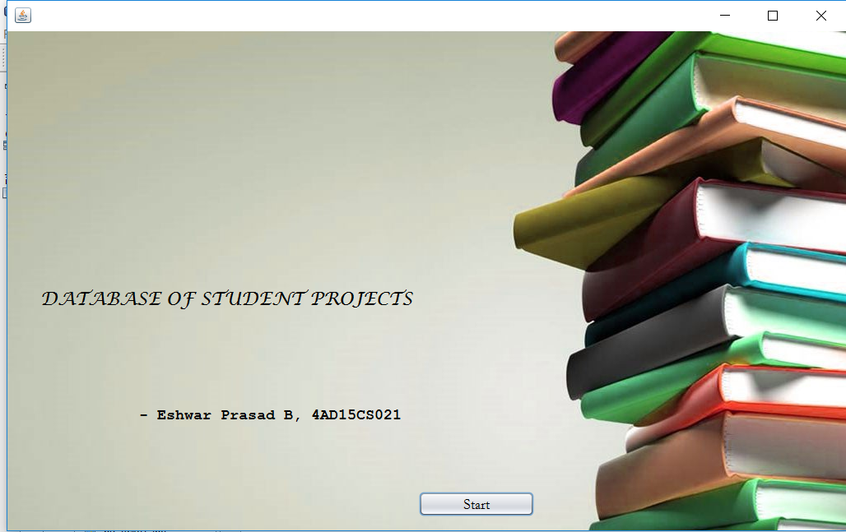

**Figure 1 welcome page**

This is the foremost page of the DATABASE OF STUDENT PROJECTS.

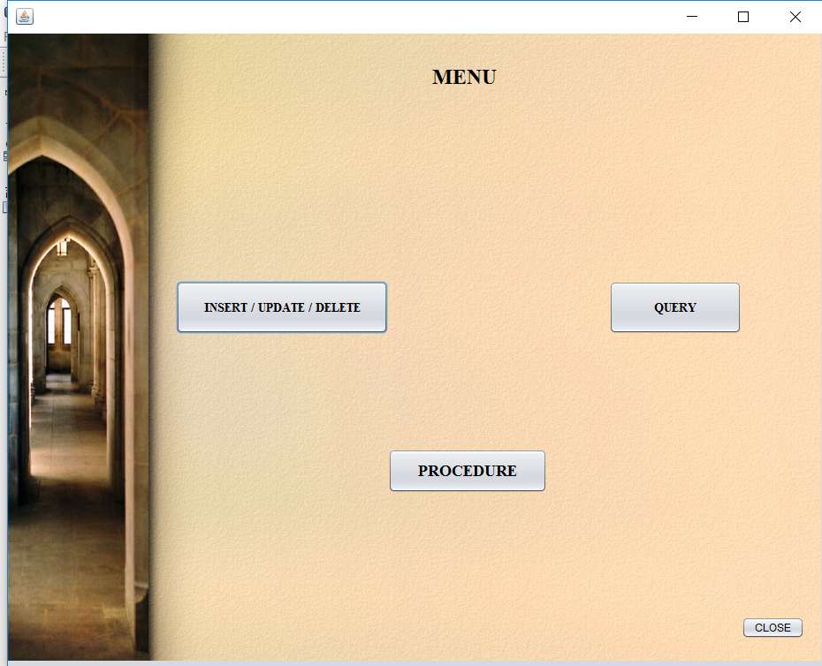

**Figure 2 Menu page**

This is the home page. This page contains Add/Update/Delete button. Also shows the procedure, and the queries button which do specific actions.

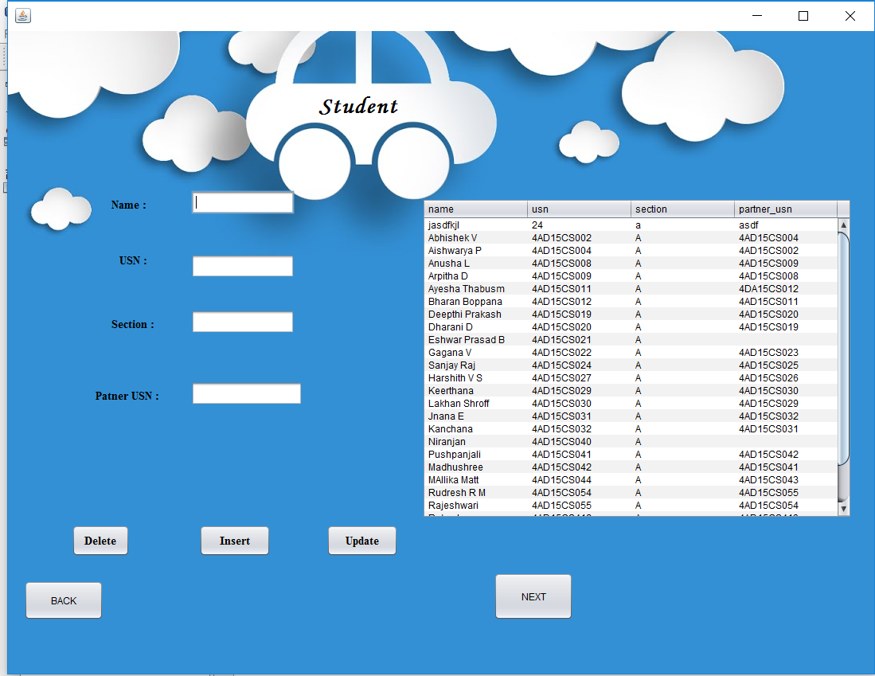

**Figure 3 Insert/Delete/Update to student**

In the above page the insertion, updating and deletion to the student will be done. This inserted/updated/deleted details will be displayed aside.

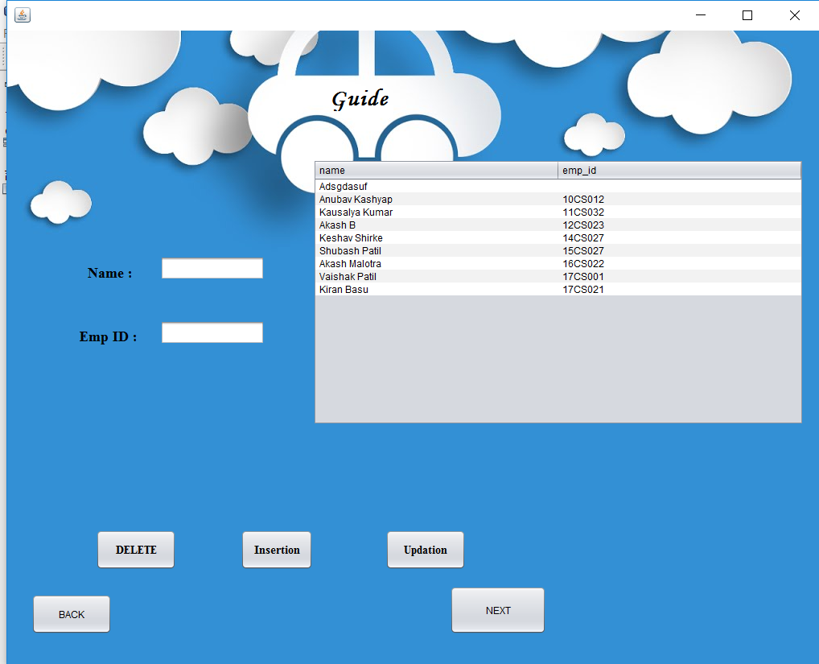

**Fig 4 Insert/Delete/Update to guide**

In the above page the insertion, updating and deletion to the guide will be done. This inserted/updated/deleted details will be displayed aside.

.

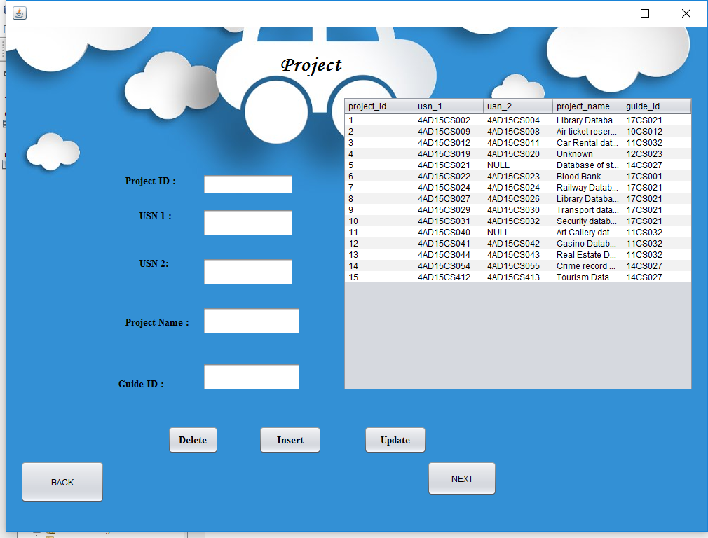

**Fig 5 Insert/Delete/Update to project**

In the above page the insertion, updating and deletion to the project will be done. This inserted /updated /deleted details will be displayed aside.

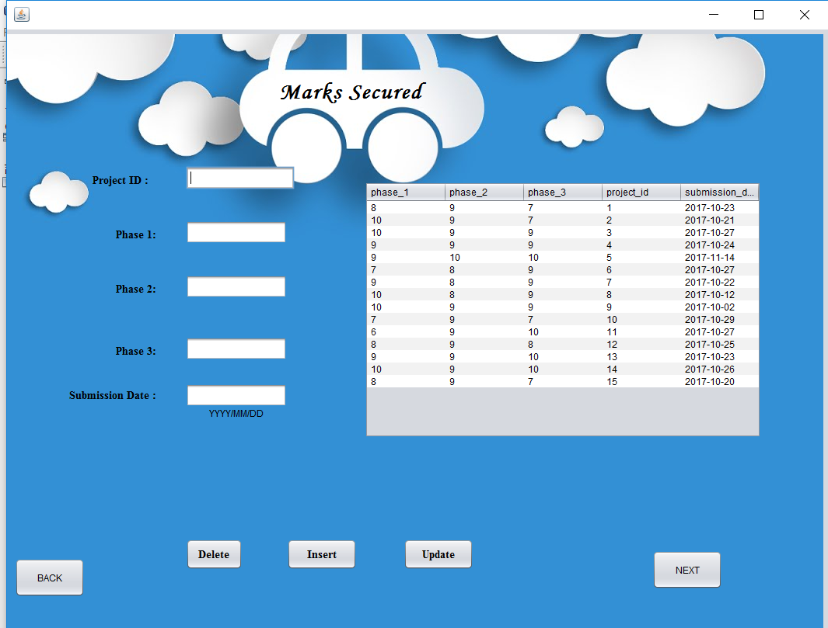

**Fig 6 Insert/Delete/Update to Marks secured**

In the above page the insertion, updating and deletion to the marks secured table will be done. This inserted /updated /deleted details will be displayed aside.

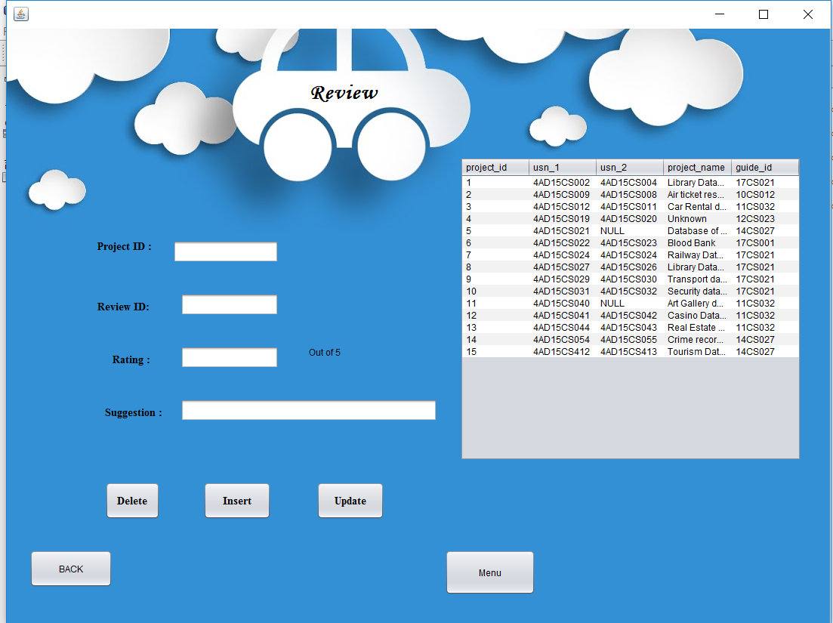

**Fig 7** **Insert/Delete/Update to review**

In the above page the insertion, updating and deletion to the marks secured table will be done. This inserted /updated /deleted details will be displayed aside.

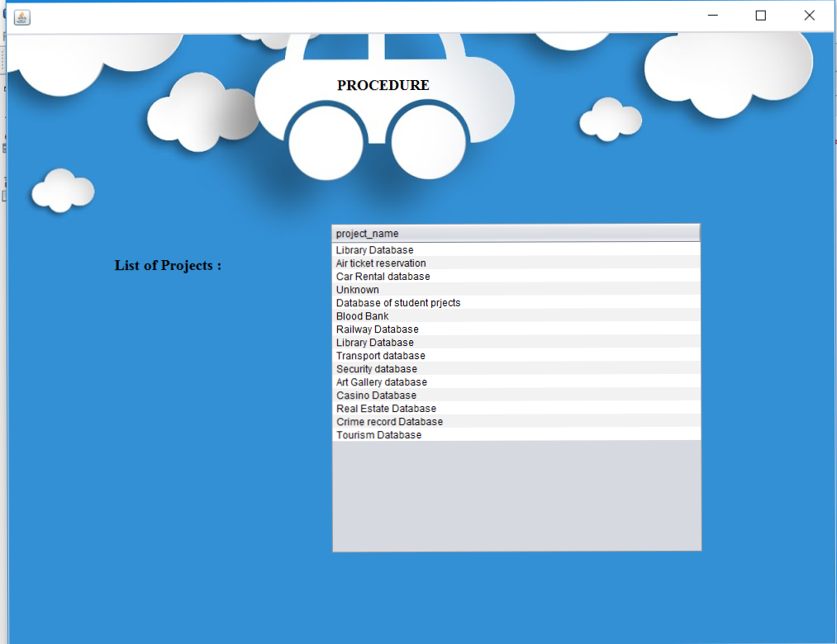

**Fig. 8 list of project names**

This displays all the project names in the database

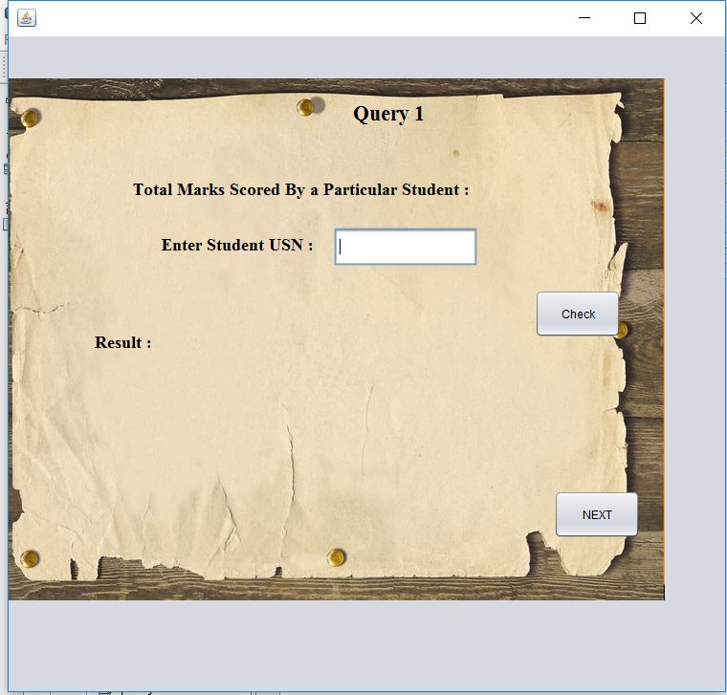

**Fig. 9 Display marks of each student**

This display the marks scored by the each student.

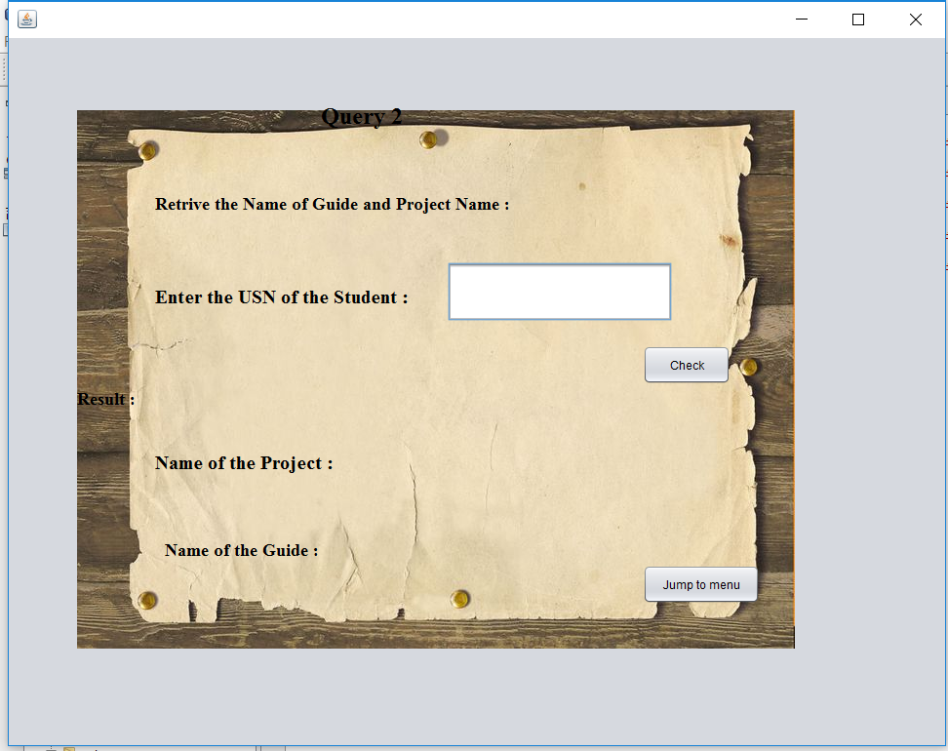

**Fig 10 Displays name and guide of project**

This displays the project name and Guide name of the particular student.

**CONCLUSION AND FUTUTRE ENHANCEMENT**

Database of student projects will be very useful for the course instructor . It is designed , implemented and tested successfully. It can be observed that the information can be retrieved successfully, accurately and easily. The project gives the complete analysis of the projects.

The application is made user friendly to the maximum so that anyone can run the application provided they could access the system. It initiates the objectives of providing the user with customized registration and process management system side software.

The software built with all options such as Insertion and retrieval of the specific information.

All the requirements specified during analysis and design phase are full met, thus resulting in the formation of good software. The system is strong enough to withstand regressive yearly operations under conditions where the database is maintained clearly over a certain time of span.

The implementation of the system in the organization will reduce the data entry, time and also provide the reports. It can be safely concluded that the interface provided is very user friendly and flexible for all times.

**REFERENCES**

**BOOKS**:

* Herbert Schildt(2007)’ Java Complete Reference’ Tata McGrawHill.
* Jim Keogh(2007)’ J2EE-The Complete Reference’ Tata McGraw Hill.
* RamezElmasri and Shamkant B. Navathe(2017)’ Database systems Models, Languages, Design and Application Programming’ Pearson.
* Korth, H.(2010) ‘Database System Concepts’ MacGrawHill.